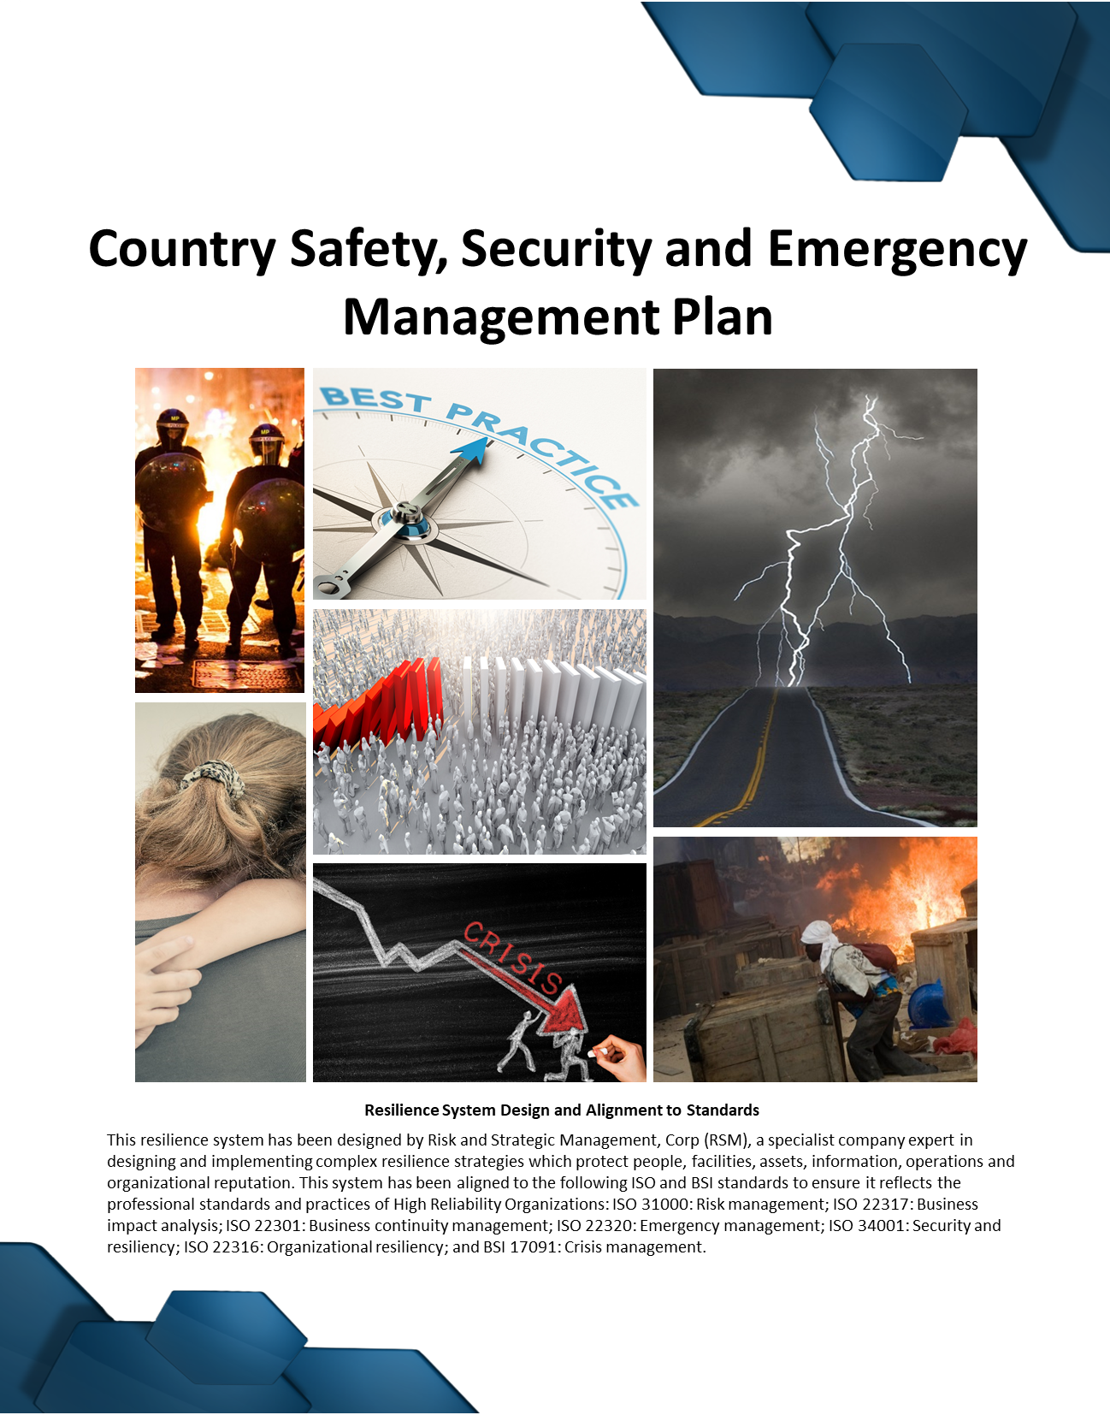


Table of Contents
Introduction 2
Part 1. Roles and Responsibilities 3
Part 2. Crisis Communications and Stakeholder Management 3
Part 3. Facility Safety and Security Management 6
Part 4. Travel Risk Management 8
Part 5. Training and Exercising 10
Part 6. Cash Management Protocol 11
Part 7. Information Security 11
Part 8. Branding Policy 11
Part 9. Medical Treatment and Emergencies 12
Part 10. Hibernation, Relocation and Evacuations 13

Appendix 1: Office Safety and Security Measures 14
Appendix 2: Mapping of Office and Residence Locations 16
Appendix 3: Medical Infrastructure Mapping 17
Appendix 4: Diplomatic Locations 18
Appendix 5.1: Hibernation and Evacuation Mapping (National) 19
Appendix 5.2: Hibernation and Evacuation Mapping (Local Area) 20
Appendix 6: Incident (Emergency) Management Response Flow-Chart 21
Appendix 7: Travel Risk Management Flow-Chart 22

Organization: | Insert
Country: | Insert
Activity Name: | Insert
Contract No: | Insert
Plan Owner: | Insert
Email: | Insert
Phone: | Insert
Plan Dated: | Insert

Document Register: Managers should reference the Document Register to identify supporting plans, guidelines, protocols, templates and infographics of relevance.

Introduction
This country Safety, Security and Emergency Management Plan (SSEMP) is part of the INSERT THE ORGANIZATIONAL NAME, COUNTRY AND ACTIVITY NAME HERE resilience and business continuity management system and is focused on activity safety, security and emergency management. This Plan seeks to capture specific decisions, responsibilities and information, the rationale behind which is found with the overarching standards, practices and guidance contained in the Organizational Safety, Security and Emergency Management Guide. Information relating to humanmade and natural risks are found within the Risk Register and Treatment Plan which will be updated annually, or as events dictate.
It is the responsibility of the senior manager and Security Manager (SM) or Security Focal Point [SFP] to confirm that all information contained within this Plan is accurate. The headquarters Security Function is also responsible for supporting the development and maintenance of this Plan.
Other remarks here

NOTE: All listed documents will be shown in bold italics for ease of cross-referencing.
UPDATES: This Plan must be updated on the 10th of January each year, or as conditions warrant change.
MAPPING: A PowerPoint mapping template has been provided – images will be converted and placed in this Plan.
Incident Severity Ratings:
- Level 1: Catastrophic and always led by the headquarters Crisis Management Leadership Team
- Level 2: Very Serious, may be lead either by the headquarters or field team
- Level 3: Serious, normally led by the field Local Incident Management Team

User Guidelines: Instructions or examples are highlighted in GREEN to support the field team in quickly and effectively completing this Plan.

Part 1. Roles and Responsibilities
In addition to the standard roles and responsibilities defined within the Safety, Security and Emergency Management Guidelines, the following unique roles and responsibilities exist for this project:
Country Management Team | Headquarters Management Team
- Liaise with local client management team  - Engage local security and safety resources  - Lead tactical / operational incident response  - Implement emergency procurements  - Adjust work plans / processes to address risk  - Maintain the SSEMP system and activities | - Approve risk tolerances and measures  - Agree to emergency driven funding deviations  - Mobilize specialist resources during a crisis  - Lead high-impact / high-consequence incidents  - Approve international evacuations  - Approve long-term work stoppages
Security Manager (SM) / Security Focal Point (SFP) | Headquarters Security Function
- Ensure security resources effectively managed  - Maintain the SSEMP system  - Test crisis communications  - Oversee training and exercising  - Send threat alerts and trigger responses | - Monitor and audit the SSEMP system  - Provide technical direction and advise  - Support management training and exercising  - Liaise with specialist resources  - Support security vendor selection
Other remarks here
The following external stakeholders hold specific security, safety and emergency management roles and responsibilities, including those identified and engaged by both the field and headquarters teams:
Stakeholder | Responsibilities
Insert name | Insert responsibilities
Insert name | Insert responsibilities
Insert name | Insert responsibilities
Insert name | Insert responsibilities
Insert name | Insert responsibilities
Insert name | Insert responsibilities
Insert name | Insert responsibilities
Other remarks here

Part 2. Crisis Communications and Stakeholder Management
The Local Incident Management Team (LIMT) consists of:
Role | Name | Email | Phone
Senior Manager | Details here | Details here | Details here
Designate | Details here | Details here | Details here
SM / SFP | Details here | Details here | Details here
LIMT role | Details here | Details here | Details here
LIMT role | Details here | Details here | Details here
LIMT role | Details here | Details here | Details here
LIMT role | Details here | Details here | Details here
LIMT role | Details here | Details here | Details here
LIMT role | Details here | Details here | Details here
LIMT role | Details here | Details here | Details here
For staff emergency communications the Phone Tree aka Warden Plan will be used.
 | See the Warden Plan / Phone Tree
Other remarks here

The Headquarters office crisis hotline details are:
Headquarters Crisis POC | Primary: Insert here  Secondary: Insert here
The following emergency communication equipment is in place:
Communication Option | Yes | No | Remarks
- International Roaming Phone | X | X | Insert
- VOIP | X | X | Insert
- Sat Phone | X | X | Insert
- BGAN | X | X | Insert
- Mass Notification Alert | X | X | Insert
- Insert | X | X | Insert
- insert | X | X | Insert
Other remarks here
Key external stakeholder details include:
US Embassy
Regional Security Officer [RSO]
- Name: insert
- Phone: insert
- Email: insert

USAID Partner Liaison Security Officer
- Name: insert
- Phone: insert
- Email: insert

Client Contact Details
USAID CO and COR
- Name: insert
- Phone: insert
- Email: insert
Security Information Resources
Details here
- Name: insert
- Phone: insert
- Email: insert

Security Company [Guards and Mobile Security] Resources
Details here
- Name: insert
- Phone: insert
- Email: insert

Partners
Details here
- Name: insert
- Phone: insert
- Email: insert
Key Subcontractors
Details here
- Name: insert
- Phone: insert
- Email: insert
Legal Support
Details here
- Name: insert
- Phone: insert
- Email: insert

Reporting Requirements
The following reporting requirements exist:
Report Type | Recipients
 | To | Deadline
- Serious Incident Report (SIR) | COR / Headquarters CMLT / RSM | 2hrs
- Incident Report | Headquarters CMLT / RSM | 8hrs
- Road Traffic Accident Report | Headquarters PMU and HR | 8hrs
- Injury Report | Headquarters PMU and HR | 8hrs
- After Action Review Report | Headquarters PMU and HR | 72hrs
 | See the Serious Incident Report Form
 | See the Road Traffic Accident Report Form
 | See the After-Action Review Report Form
Other remarks here

Part 3. Facility Safety and Security Management
The following are project office and residence locations (see Appendix 1 and mapping):
Nature | Address | Resident Name[s]
- Office / Residences | Insert | Insert
- Office / Residences | Insert | Insert
- Office / Residences | Insert | Insert
- Office / Residences | Insert | Insert
- Office / Residences | Insert | Insert
 | See the Guide to Facility Security Standards
 | See the Fire Safety Guide
 | See the Guard Force Orders
A Facility Risk Assessment will be performed before an office or residence is selected in medium to high-risk locations.
Other remarks here

Common Office Safety and Security Equipment
All locations will have the following equipment:
- Fire detection systems and alarms  - Fight fighting equipment  - Add more | - First aid equipment  - Add more  - Add more

Hotel and Guesthouse Safety and Security
The Hotel and Guesthouse Risk Assessment form will be used to evaluate suitable short and long-term lodging in higher risk areas. The following hotels and guesthouses have been approved for use.
City | Hotel Name | Address, Website and Phone Number
Insert | Insert | Insert
Insert | Insert | Insert
Insert | Insert | Insert
Insert | Insert | Insert
Insert | Insert | Insert
Insert | Insert | Insert
Insert | Insert | Insert
Insert | Insert | Insert
Other remarks here

Part 4. Travel Risk Management
Where travel is planned to remote or high-risk locations a Risk Assessment (Travel Risk Assessment Form) will be conducted for the commonly visited locations.
Location | High Risk | Medium Risk | Low Risk
Name common location here – this then links to the vehicle configuration below. | X | X | X
Name common location here – this then links to the vehicle configuration below. | X | X | X
Name common location here – this then links to the vehicle configuration below. | X | X | X
Name common location here – this then links to the vehicle configuration below. | X | X | X
 | See the Travel Risk Assessment Form
 | See the Driver Code of Conduct
Other remarks here

Secured Transport Configurations
The following transport configurations support safe and secure transport.
No | Description | High Risk | Medium Risk | Low Risk | Remarks
1 | Insert how many vehicles and the type here, as well as any especially trained drivers and mobile security | X | X | X | Insert additional remarks here
2 | Insert how many vehicles and the type here, as well as any especially trained drivers and mobile security | X | X | X | Insert additional remarks here
3 | Insert how many vehicles and the type here, as well as any especially trained drivers and mobile security | X | X | X | Insert additional remarks here

High-Risk or Out-of-Bound Areas
The following are designated high-risk or out-of-bounds areas:
- Insert any specific locations here or state NA.

Approved Transport Providers
The following are approved passenger transport providers:
- Insert name, address, website and contact details of any approved providers.

Part 5. Training and Exercising
The following training and exercising will be provided to managers, staff and support staff to raise knowledge and reduce risks:
Learner Group | Program of Instruction | Frequency | Provider
International Short-Term Staff | Insert | Insert | Insert
 | Insert | Insert | Insert
 | Insert | Insert | Insert
International Long-Term Staff | Insert | Insert | Insert
 | Insert | Insert | Insert
 | Insert | Insert | Insert
Local Incident Management Team | Insert | Insert | Insert
 | Insert | Insert | Insert
 | Insert | Insert | Insert
 | Insert | Insert | Insert
Security Managers or Security Focal Points | Insert | Insert | Insert
 | Insert | Insert | Insert
 | Insert | Insert | Insert
Local Staff | Insert | Insert | Insert
 | Insert | Insert | Insert
 | Insert | Insert | Insert
 | Insert | Insert | Insert
 | Insert | Insert | Insert
Drivers | Insert | Insert | Insert
 | Insert | Insert | Insert
 | Insert | Insert | Insert
Guards | Insert | Insert | Insert
 | Insert | Insert | Insert
 | Insert | Insert | Insert
 | See the Training Record Card
Insert additional comments here on training and exercising

Part 6. Cash Management Protocol
The following governs cash management:
Risk Point | Mitigation Strategy
Cash withdrawals | - Information security  - Secured transport
Cash storage | - Cash box / safe
Cash payments | - Information security  - Security for amounts over $XXXX
Other remarks here

Part 7. Information Security
The following information security controls will be used for this project:
Instigated |  | Risk Control Measure
Yes | No
X | X | AuP Policy signed by all staff
X | X | AuP training provided to all staff
X | X | Clear desk policy
X | X | Sensitive information secured in lockable containers
X | X | Password protected IT
X | X | Encrypted IT
X | X | Sensitive information not taken on trips with risk exposure
X | X | Paper copies of information shredded
X | X | IT asset destruction protocol (magnetic wiping and destruction) implemented
Other remarks here

Part 8. Branding Policy
Where branding may elevate risks then the following risk controls or actions will be implemented.
Location or Operating Areas | Branding Required
 | YES | NO
Insert risk controls or actions | X | X
Insert risk controls or actions | X | X
Insert risk controls or actions | X | X
Insert risk controls or actions | X | X
Insert risk controls or actions | X | X
Other remarks here

Part 9. Medical Treatment and Emergencies
The following are approved doctors, dentists and medical center / hospitals:
Type | City | Address | Phone | Website
Hospitals | Insert | Insert | Insert | Insert
 | Insert | Insert | Insert | Insert
 | Insert | Insert | Insert | Insert
 | Insert | Insert | Insert | Insert
 | Insert | Insert | Insert | Insert
Doctors | Insert | Insert | Insert | Insert
 | Insert | Insert | Insert | Insert
 | Insert | Insert | Insert | Insert
 | Insert | Insert | Insert | Insert
Dentists | Insert | Insert | Insert | Insert
 | Insert | Insert | Insert | Insert
 | Insert | Insert | Insert | Insert
Other remarks here

The following insurances are provided to international and local staff:
Broker / Underwriter | Policy Number | Type | Website
Insert | Insert | Insert | Insert
Insert | Insert | Insert | Insert
Other remarks here

Part 10. Hibernation, Relocation and Evacuations
The Hibernation, Relocation and Evacuation Management (HRE) Guideline is used to guide managers through decision-points in an emergency situation. The following outlines specific locations and routes used for this activity:
Safe Havens: | Insert name, address, website, type of location and contact details.
Land Routes: | Insert name and description of land-crossing points.
Air Routes: | Insert name and description of air evacuation options.
Maritime Options: | Insert name and description of maritime-evacuation options.
Vendors: | Name vendors identified for support.
Mutual Aid Agreements: | List any Mutual Aid Agreement with other organizations.
Notes, Recommendations and Directives
List any specific notes, recommendations or directives associated with this project.
See HRE Mapping.
 | See the Manager’s Guide to Hibernation, Relocation and Evacuations
 | See the Staff Guide to Hibernation, Relocation and Evacuations

Appendix 1: Office Safety and Security Measures
The following measures will be taken to secure offices, residences and warehousing (as required).
Location Name and Address: | Insert name or address of the location and what it is
Office Security Measure | Description and Provider
- Grounds access controls | Insert details
- Perimeter security | Insert details
- Door security | Insert details
- Window Security | Insert details
- Security Lighting | Insert details
- Security Buzzer Systems | Insert details
- Panic Alarms | Insert details
- CCTV | Insert details
- Intruder Detection Alarms | Insert details
- Guards | Insert details
- Search Equipment | Insert details
- Safe Rooms or Areas | Insert details
- Medical Kits | Insert details
- Fire Alarms / Firefighting | Insert details
- Local Safe Haven | Insert details
- Nearest Medical Support | Insert details

Location Name and Address: | Insert name or address of the location and what it is
Office Security Measure | Description and Provider
- Grounds access controls | Insert details
- Perimeter security | Insert details
- Door security | Insert details
- Window Security | Insert details
- Security Lighting | Insert details
- Security Buzzer Systems | Insert details
- Panic Alarms | Insert details
- CCTV | Insert details
- Intruder Detection Alarms | Insert details
- Guards | Insert details
- Search Equipment | Insert details
- Safe Rooms or Areas | Insert details
- Medical Kits | Insert details
- Fire Alarms / Firefighting | Insert details
- Local Safe Haven | Insert details
- Nearest Medical Support | Insert details

add or delete more as needed…

Appendix 2: Mapping of Office and Residence Locations

Insert mapping here: ensure images are optimized to reduce file size

Appendix 3: Medical Infrastructure Mapping

Insert mapping here: ensure images are optimized to reduce file size

Appendix 4: Diplomatic Locations
Insert mapping here: ensure images are optimized to reduce file size

Appendix 5.1: Hibernation and Evacuation Mapping (National)

Insert mapping here: ensure images are optimized to reduce file size

Appendix 5.2: Hibernation and Evacuation Mapping (Local Area)

Insert mapping here: ensure images are optimized to reduce file size

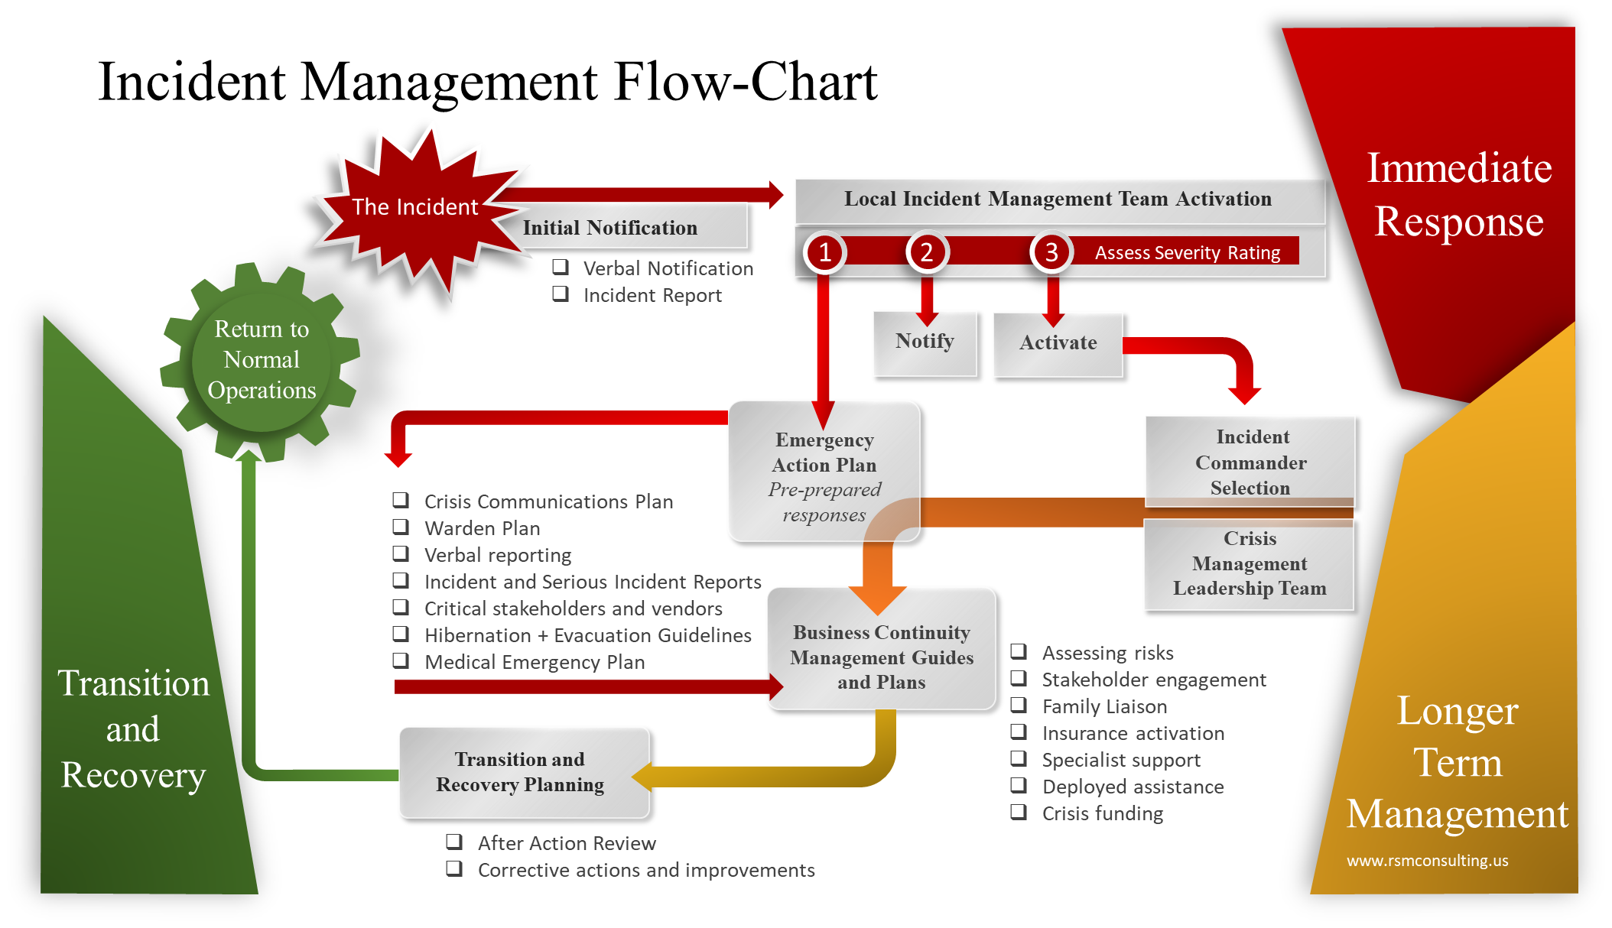
Appendix 6: Incident (Emergency) Management Response Flow-Chart

Appendix 7: Travel Risk Management Flow-Chart
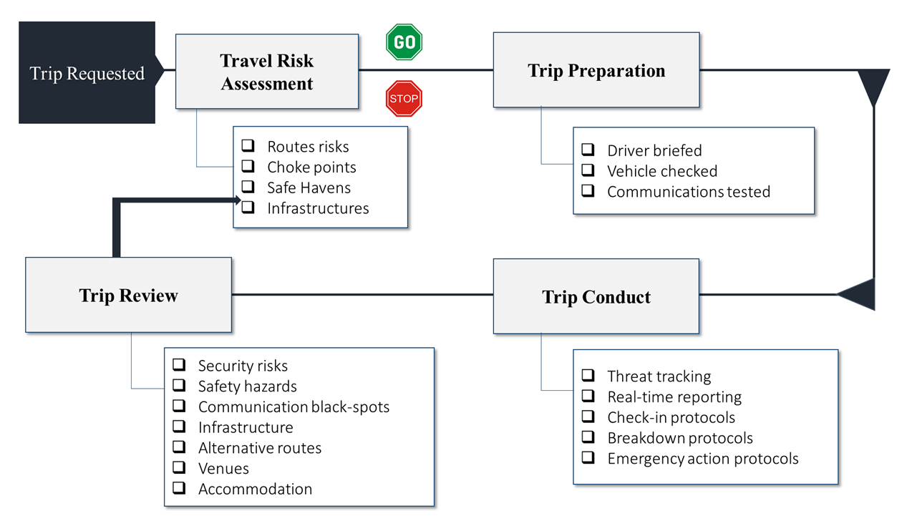

Crisis Management Leadership Team (CMLT) or Local Incident Management Team (LIMT)
Ensure these align to insurance coverages where appropriate

